1. Space needed. “SimplifyRent” Needs to have a space in between the words. “Simplify Rent”

: Done

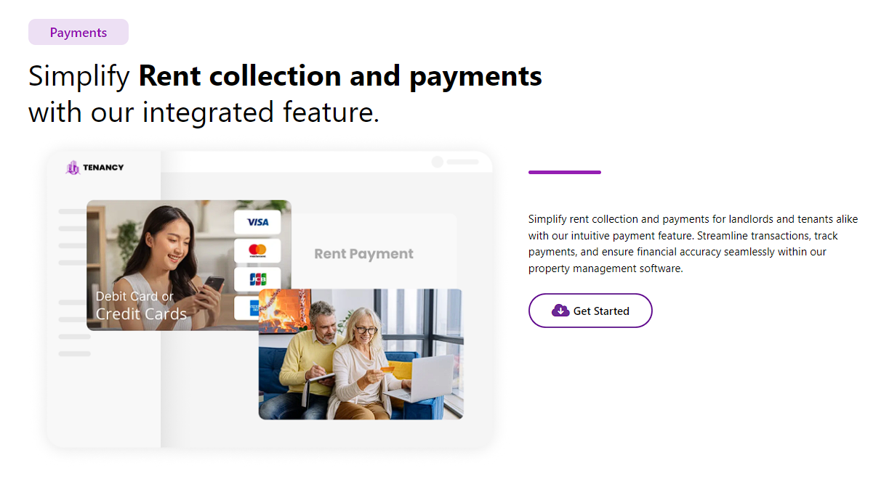

1. Get started should direct the user to “Plans and Pricing” the only get started link that does this is Expenses. All Get started Links should direct the user to plans and pricing. Here is the message that I receive when I click get started.

Response :done

1. Rewording needed. Under correspondence, Please change the following:

“We can give the best facilitie for you!”

With

“Real-time communication hub with centralized inbox and priority tagging.”  
  
: done

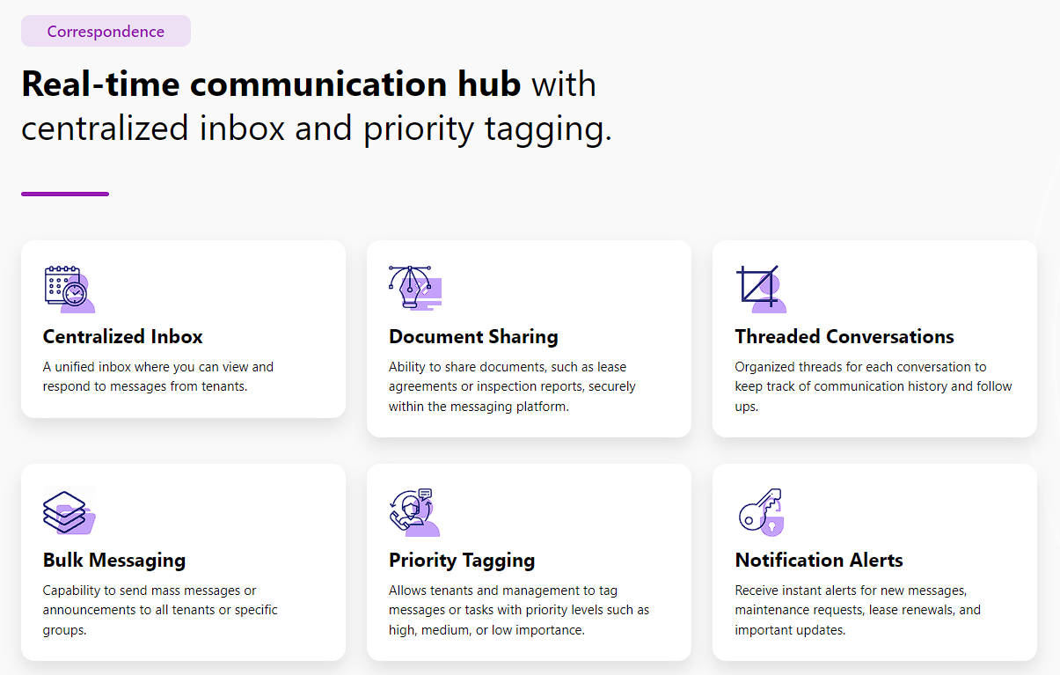­

1. Lower case letter needed. Under Reporting, please change the upper case “F” to a lower case “f”

: done

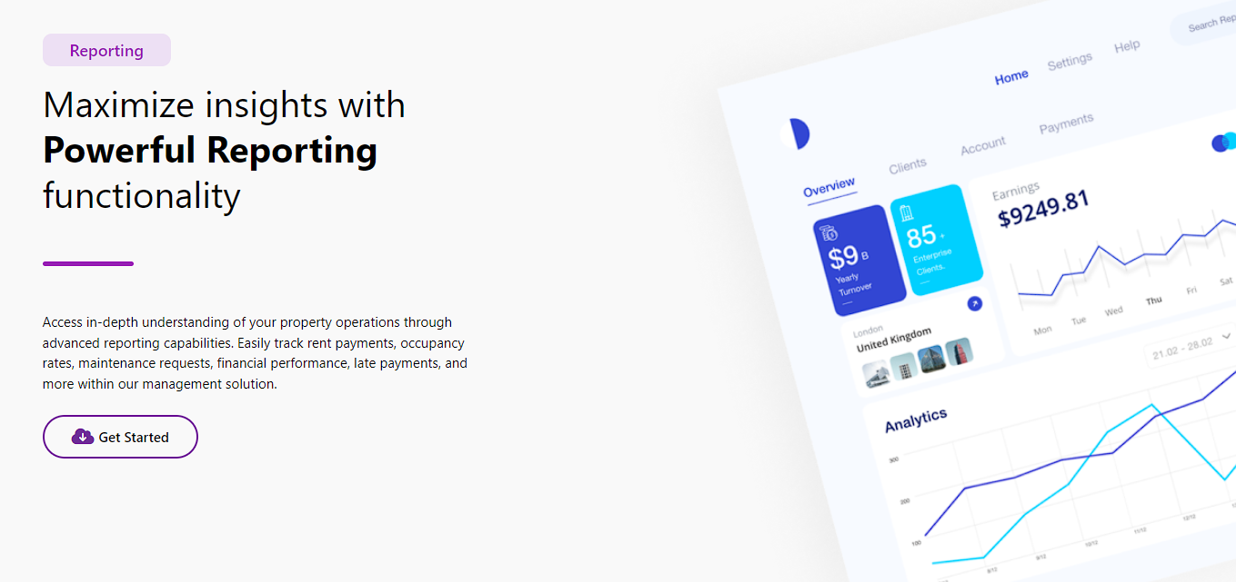

1. The circled linked links at the bottom should take the user at the level where that feature is presented. Can you please bring the user up to where the shade begins. Please see the 2 examples below:

**Current**

**Desired**

**Current**

**Desired**

: done

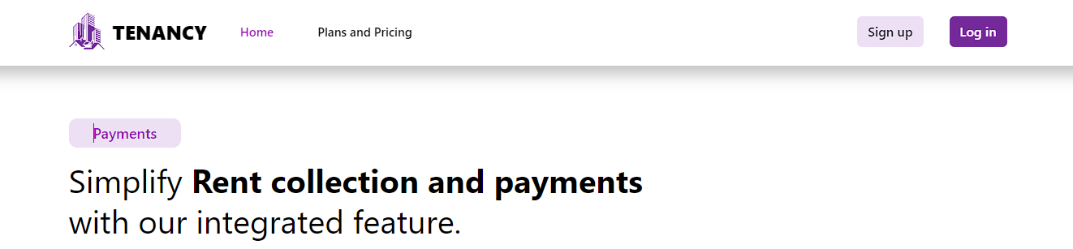

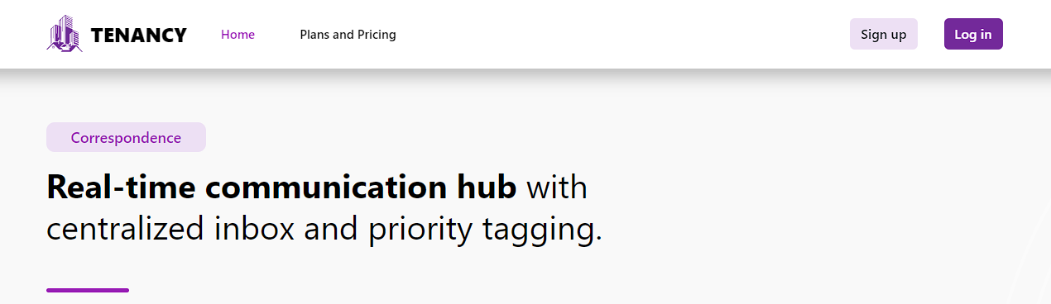

1. The Favicon needed: Please use the favicon on all tenancy pages. This also includes all pages where the user is logged in.



Response:done

Response: done, kindly do hard refresh to the page.

1. Misspelling: Please correct the spelling of “Tanant” to “Tenant”

Response done: https://prnt.sc/K3N1DxHXL5wq

1. Either “Home” or “Plans and Pricing” links should be highlighted when the user clicks on the page. If the user is on Home then the Home link should be highlighted, if the user is on Plans and Pricing then the Plans and Pricing link should be highlighted. Also we are missing the favicon on Plans and Pricing page. A screenshot of a computer

   Description automatically generated

Response-done: https://prnt.sc/jIzNnVoQGehB

: done

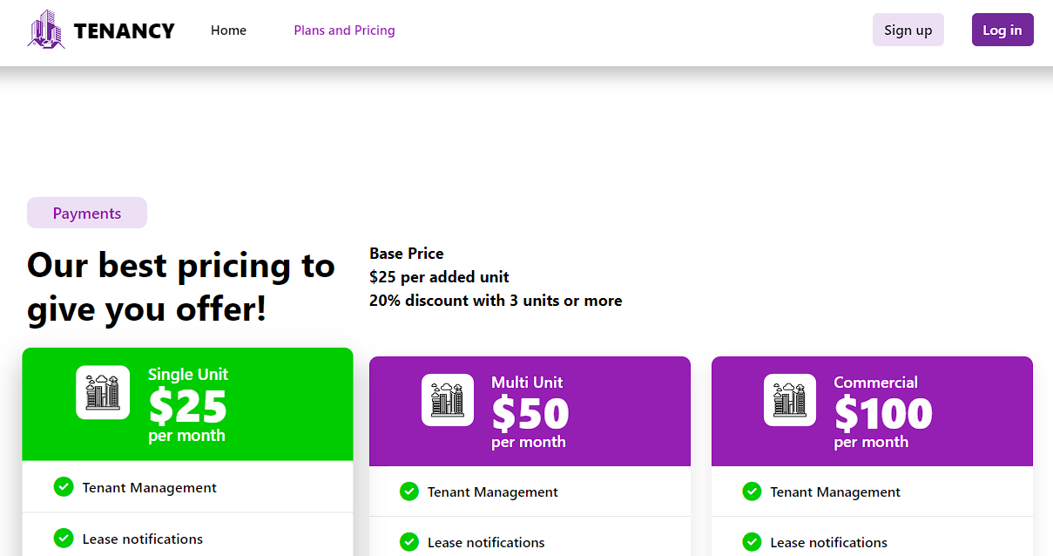

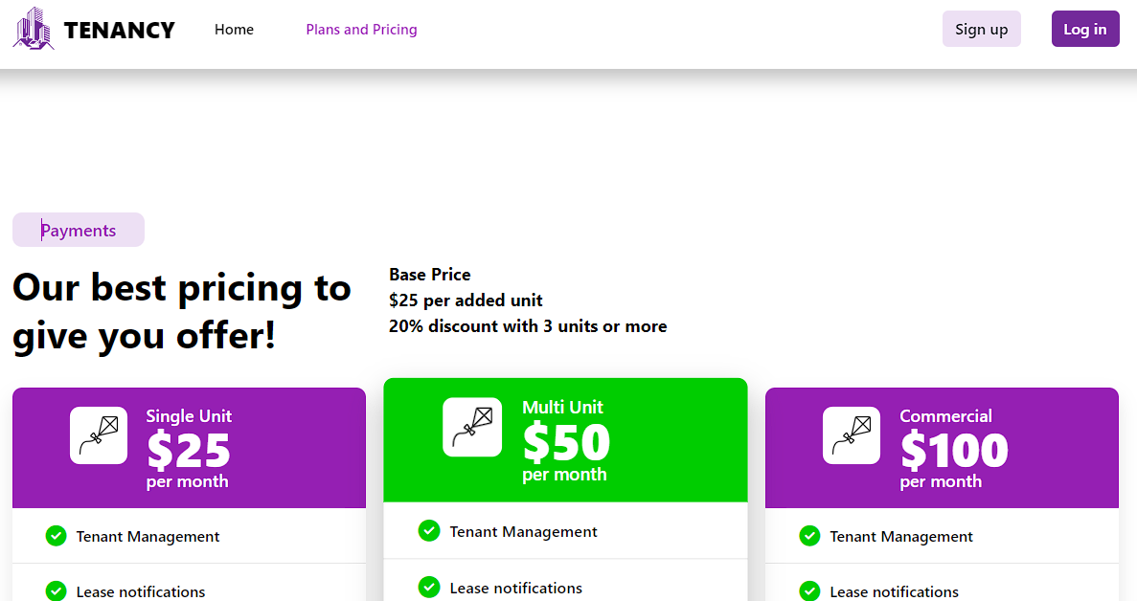

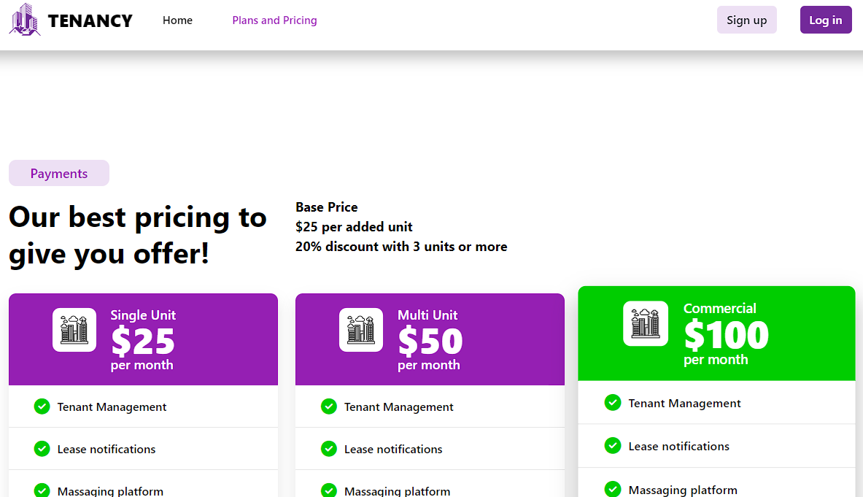

1. Account ID – should be numeric values only. These numbers are assigned when a new user signs up for the application. Please make the account ID 17 digits long numeric values only. E.g. “00000001121556661”

Response done: <https://prnt.sc/BUL0zJgKBGmg>

1. Do not clear out all fields due to an error on a field or a required field is left blank. This forces the user to have to re enter all their information.

Response:done

1. Please change the notification message to “Are you sure you want to delete this expense?”

Response done: <https://prnt.sc/Sg6Kw_0sEMfi>

1. Add a cancel button on this page – When the user has selected an expense, then clicks edit, then clicks cancel, then clicks cancel again, the cancel button takes them into edit mode. I would expect that the cancel button takes the user back to expenses page.

Response:done

1. Expense- Date – Highlight after the date is selected. The date is not visible after the date is selected. Not satisfied with the way the date format is functioning. The user is forced to click into each “/” in order to type in the date. I would like the user to be able to press the back space key to remove each date by character. I also still will want the user to have the ability to select a date.

Response:done

1. The user should be able to hover over expense and it should be highlightable.

response - https://prnt.sc/FK31KJz6z0yS Still needs pointer finger the same way view property screen has.